**Adding a Custom Cursor to a VB Project**

In VB, there are a couple options that you have for changing the cursor.

**Method 1 – Using Built-In Cursors**

**Design Time**

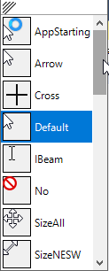VB has several different pre-made cursors that you can choose from. Select your **Form**, and then find the **Cursor** property in the **Properties** menu:

You can select any of the pre-made cursors at design time. This will determine

what the cursor will look like when you start your program. There are many

cursors here to choose from. Sometimes however, you may want

to change the cursor at run-time.

**Run Time**

To do this, simply set the Cursor property of your Form using the following code:  
(*You may put this line of code in any event procedure*)

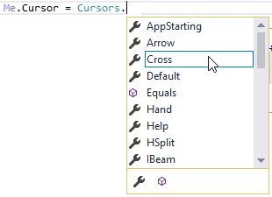

Choose any cursor you want.

*Things to try:*

1. Use the events MouseEnter/MouseLeave/MouseHover to change the cursor using different events of various controls such as PictureBoxes, Labels and Buttons.
   * If you want your program to remember what the previous cursor was so you can return to it in a MouseLeave event, make a cursor variable and save it

At the top of your program.

Dim prevCursor As Cursor

Put this before you change the Cursor to something else if you intend on changing it back.

prevCursor = Me.Cursor

This will revert your cursor to whatever it was before.

Me.Cursor = prevCursor

**Method 2 – Creating a Custom Cursor**

**Creating a Cursor from an Image**

You can create a cursor from any image you like. There are a couple important things to be aware of here:

1. The cursor will be the actual size of the image in pixels. This means that you will probably need to use photo-editing software to resize the image to an appropriate size.
2. You will have to make any part of the image transparent that you don’t want to see.
3. 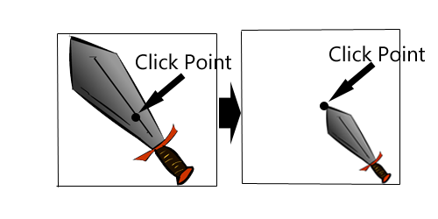Lastly, and most important, the click point will be the **MIDDLE** of the image, NOT the upper right corner as with a .cur file.
   * To address this, you can open your image in photo-editing software and shrink/move the image so that the spot on the image where you want the click point to be is actually in the middle of the canvas, and make the rest transparent.

To use an image as your cursor, add it to your project resources. Use the following line of code to change the cursor to the image from your resources:

Me.Cursor = New Cursor(My.Resources.crosshair.GetHicon)

This converts the image into a format that can be used as a cursor.

The image you want to use in resources.

**Use an Existing .cur File**

Note that this method will render cursors in black and white only.

Find/Download a .cur file of your choice (or use *the cursor.cur* file I have provided) and add it to your Project Resources.

At the top of your program, create a variable that you will use to point to the .cur file you added:

Dim flame_cursor As IO.MemoryStream

Add the following code to whatever event you wish to change the cursor in:

flame_cursor = New IO.MemoryStream(My.Resources.cursor)

Me.Cursor = New Cursor(flame_cursor)

The cursor (.cur) file you added to the project resources.